**APEX COLLEGE**

**POKHARA UNIVERSITY**

**LAB REPORT OF**

**DOT NET TECHNOLOGY**

**LAB -2**

**Submitted By: Submitted To:**

**Remisha Maharjan Bishwomitra Adhikari**

**BCIS ‘Adware’ Ananta Pant**

**Roll no: 17**

**OBJECTIVE:-**

TO GET FAMILIAR WITH MVC FRAMEWORK

1.Make a model

**Check.cs**

**using System;**

**namespace lab1_mvc.Models**

**{**

**public class Check**

**{**

**public int a { get; set; }**

**}**

**}**

2. In controller make an object to display odd or even number..

**HomeController.cs**

**using System;**

**using System.Collections.Generic;**

**using System.Diagnostics;**

**using System.Linq;**

**using System.Threading.Tasks;**

**using Microsoft.AspNetCore.Mvc;**

**using lab1_mvc.Models;**

**namespace lab1_mvc.Controllers**

**{**

**public class HomeController : Controller**

**{**

**[HttpPost]**

**public IActionResult Check(int a)**

**{**

**var r ="even";**

**if(a%2==0)**

**// return View("even");**

**r="even";**

**else**

**r="odd";**

**ViewBag.Result=r;**

**return View();**

**}**

**[HttpGet]**

**public IActionResult Check()**

**{**

**return View();**

**}**

**public IActionResult Privacy()**

**{**

**return View();**

**}**

**[ResponseCache(Duration = 0, Location = ResponseCacheLocation.None, NoStore = true)]**

**public IActionResult Error()**

**{**

**return View(new ErrorViewModel { RequestId = Activity.Current?.Id ?? HttpContext.TraceIdentifier });**

**}**

**}**

**}**

3. Showing the output in the view

**Check.cshtml**

**@model lab1_mvc.Models.Check**

**@{**

**ViewData["Title"] = "Check Page";**

**}**

**@using (Html.BeginForm())**

**{**

**<input type="text" name="a">**

**<input type="submit" name="submit" value="Check Even or Odd" class="btn btn-info">**

**}**

**@{**

**var result =ViewBag.Result;**

**<p>@result</p>**

**}**

**OUTPUT**

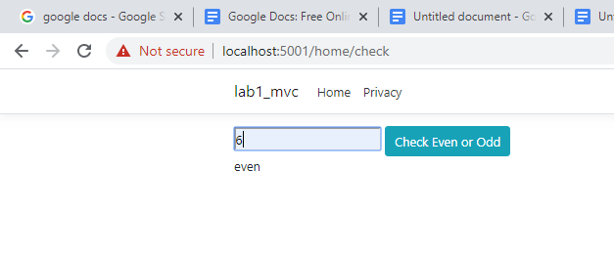

**CONCLUSION**

In lab 2, we learned to use basics of mvc framework to find the odd or even number.